Typical Features |  |  |  | 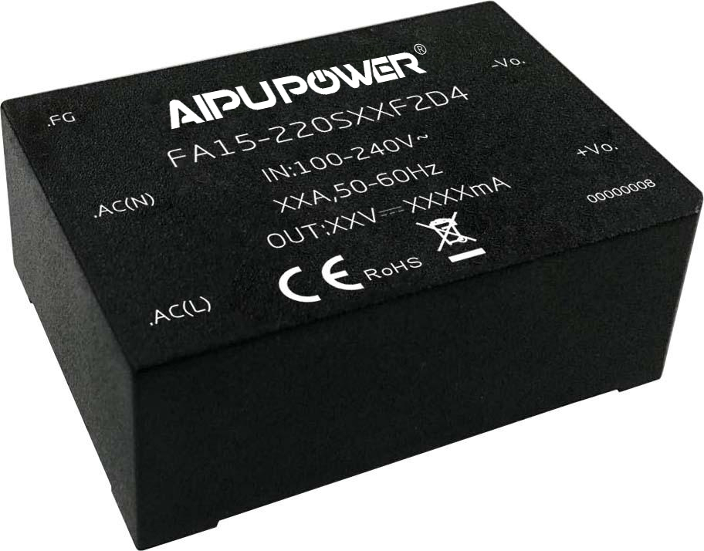  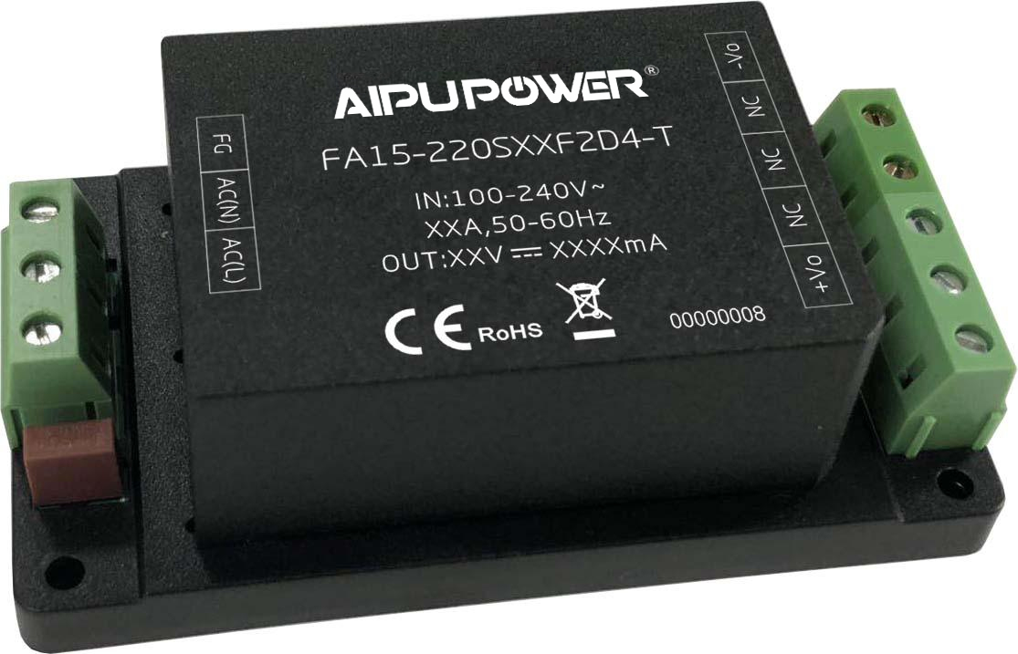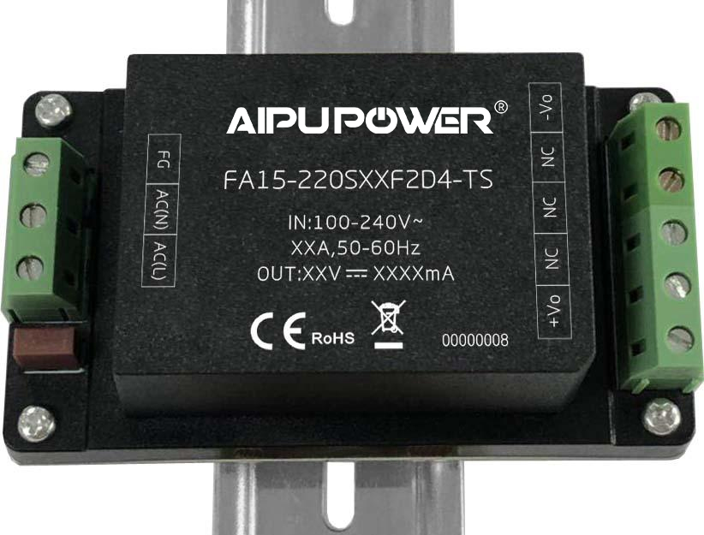
◆ Wide input voltage range 85-265VAC/120-380VDC
◆ No-load power consumption ≤0.35W
◆ Efficiency 86% (typ.)
◆Operating temperature from -40℃ to +75℃
◆ Switching frequency 65KHz
◆ Short Circuit & Over Current protections
◆ Isolation voltage 4000VAC
◆ Altitude during operating 4000m Max
◆ With CE Certificate & conform to RoHS regulation
◆ Compliant with IEC/EN62368/UL62368
◆ Encapsulated in plastic case, flame class UL94 V-0 |  |  |  | 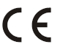  
◆ PCB DIP mounting
Application Field
FA15-220SXXF2D4 Series----- Compact size & high efficiency modular power supplies with global adapted input voltage range (both AC & DC available), low ripple, low temperature rise, low standby power consumption, high efficiency, high reliability, safety isolated and good EMC performance. This series of products can be widely used in the fields of electric power, industrial, instrument, smart home devices, etc. The additional circuit for EMC is recommended in this data sheet for the application with high EMC requirement.
Typical Product List
Certificate | Part No. | Output Specification |  |  |  | Max. Capacitive Load | Ripple& Noise 20MHz  (Max.) | Efficiency@ Full Load, 220Vac  (Typ.)
Certificate | Part No. | Power | Voltage |  | Current | Max. Capacitive Load | Ripple& Noise 20MHz  (Max.) | Efficiency@ Full Load, 220Vac  (Typ.)
Certificate | Part No. | （W） | Vo（V） |  | Io（mA） | uF | mVp-p | %
CE | FA15-220S3V3F2D4 | 10 | 3.3 |  | 3000 | 2000 | 80 | 70
CE | FA15-220S05F2D4 | 15 | 5 |  | 3000 | 1000 | 80 | 74
CE | FA15-220S09F2D4 | 15 | 9 |  | 1667 | 1000 | 80 | 82
CE | FA15-220S12F2D4 | 15 | 12 |  | 1250 | 800 | 80 | 84
CE | FA15-220S15F2D4 | 15 | 15 |  | 1000 | 800 | 100 | 85
- | FA15-220S20F2D4 | 15 | 20 |  | 750 | 800 | 100 | 85
CE | FA15-220S24F2D4 | 15 | 24 |  | 625 | 500 | 100 | 86
Note 1 - The suffix -T is for a kind of chassis packaging, -TS is for a kind of packaging of DIN Rail which width is 35mm.
Note 2 - The typical value of efficiency is based on the product tested after half an hour burn-in at full load.
Note 3 - The full load efficiency should be in ±2% of the typical value in this table. The efficiency is calculated by the way that the full output power is divided by the input power.
Note 4 - Please contact Aipu sales for other output voltages requirement in this series but not listed in this table.

Input Specifications
Item |  | Operating Condition |  | Min. |  | Typ. |  | Max. |  | Unit
Input Voltage Range |  | AC Input |  | 85 |  | 220 |  | 265 |  | VAC
 |  | DC Input |  | 120 |  | 310 |  | 380 |  | VDC
Input Frequency Range |  | - |  | 47 |  | 50 |  | 63 |  | Hz
Input Current |  | 115VAC |  | - |  | - |  | 0.35 |  | A
 |  | 220VAC |  | - |  | - |  | 0.25 |  | A
Surge Current |  | 115VAC |  | - |  | - |  | 10 |  | A
 |  | 220VAC |  | - |  | - |  | 20
Standby power consumption |  | 115VAC |  | - |  | - |  | 0.35 |  | W
 |  | 220VAC |  | - |  | -
Leakage Current |  | - |  | 0.5mA TYP/230VAC/50Hz
Recommended Fuse |  | - |  | 1A-2A/250VAC Time-delay fuse
Hot plug |  | - |  | Unavailable
Remote control |  | - |  | Unavailable
Output Specifications
Item |  |  | Operating Condition |  | Min. |  | Typ. |  | Max. |  | Unit
Voltage Accuracy |  |  | Full input voltage range,  any load | Vo | - |  | ±2.0 |  | ±3.0 |  | %
Line Regulation |  |  | Rated Load | Vo | - |  | - |  | ±0.5 |  | %
Load Regulation |  |  | Nominal input voltage,  20%~100% load | Vo | - |  | - |  | ±1.0 |  | %
Minimum load |  |  | Single Output |  | 0 |  | - |  | - |  | %
Turn-on Delay Time |  |  | Input 115VAC (full load) |  | - |  | 1000 |  | - |  | mS
 |  |  | Input 220VAC (full load) |  | - |  |  |  | - |  | mS
Power-off Hold up Time |  |  | Input 115VAC (full load) |  | - |  | 200 |  | - |  | mS
 |  |  | Input 220VAC (full load) |  | - |  |  |  | - |  | mS
Dynamic  Response | Overshoot range |  | 25%~50%~25%  50%~75%~50% |  | -10.0 |  | - |  | +10.0 |  | %
Dynamic  Response | Recovery time |  |  |  | -5.0 |  | - |  | +5.0 |  | mS
Output Overshooting |  |  | Full input voltage range |  | ≤10%Vo |  |  |  |  |  | %
Short Circuit Protection |  |  | Full input voltage range |  | Continuous, Self-recovery |  |  |  |  |  | Hiccup
Drift Coefficient |  |  | - |  | - |  | ±0.03% |  | - |  | %/℃
Over Current Protection |  |  | Full input voltage range |  | ≥120% Io, Self-recovery |  |  |  |  |  | Hiccup
Ripple & Noise |  |  | - |  | - |  | 50 |  | 100 |  | mV
 |  |  | Note - The ripple and noise are tested by the twisted pair method. For details understood, please refer to the following Ripple & Noise Test Instructions.

General Specifications
Item |  | Operating Condition | Min. | Typ. | Max. | Unit
Switching Frequency |  | - | - | 65 | - | KHz
Operating Temperature |  | Refer to the Temperature Derating Curve | -40 | - | +75 | ℃
Storage Temperature |  | - | -40 | - | +85 | ℃
Soldering Temperature |  | Wave-soldering | 260±4℃, timing 5-10S
 |  | Datasheet-soldering | 360±8℃, timing 4-7S
Relative Humidity |  | - | 10 | - | 90 | %RH
Isolation Voltage | I/P-O/P | Test 1min, leakage current ≤5mA | 4000 | - | - | VAC
Insulation Resistance | I/P-O/P | @DC500V | 100 | - | - | MΩ
Safety Standard |  | - | IEC/EN62368
Vibration |  | - | 10-55Hz,10G,30 Min, along X,Y,Z
Safety Class |  | - | CLASS Ⅱ
Flame Class of the Case |  | - | UL94 V-0
MTBF |  | - | MIL-HDBK-217F@25℃＞300,000H
Unit Weight |  | Part No. | Weight (TYP)
 |  | FA15-220SXXF2D4 | 95g
 |  | FA15-220SXXF2D4-T | 130g
 |  | FA15-220SXXF2D4-TS | 150g

EMC Performance
Total Item |  | Sub Item | Test Standard | Performance/Class
EMC | EMI | CE | CISPR32/EN55032 | CLASS B (with Recommended Circuit 2)
EMC | EMI | RE | CISPR32/EN55032 | CLASS B (with Recommended Circuit 2)
EMC | EMS | RS | IEC/EN61000-4-3 | 10V/m Perf.Criteria B (with Recommended Circuit 1)
EMC | EMS | CS | IEC/EN61000-4-6 | 3Vr.m.s Perf.Criteria B (with Recommended Circuit 1)
EMC | EMS | ESD | IEC/EN61000-4-2 | Contact ±6KV / Air ±8KV Perf.Criteria B
EMC | EMS | Surge | IEC/EN61000-4-5 | ±1KV Perf.Criteria B
EMC | EMS | EFT | IEC/EN61000-4-4 | ±2KV Perf.Criteria B
EMC | EMS | Voltage dips and interruptions | IEC/EN61000-4-11 | 0%~70% Perf.Criteria B

F2 Packaging Dimensions
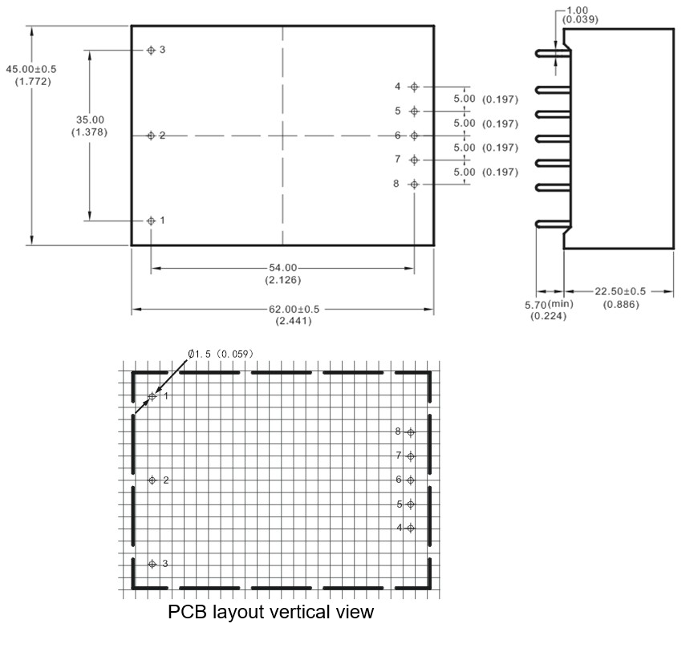
Unit: mm(inch)
Grid 2.54x2.54(0.10x0.10)
Pin diameter tolerance ±0.10(±0.004)
General tolerance ±0.50(±0.020)
Pin No. | Function
1 | FG (No function)
2 | AC(N)
3 | AC(L)
4 | +Vout
5 | No pin
6 | No pin
7 | No pin
8 | -Vout
F2-T Packaging Dimensions
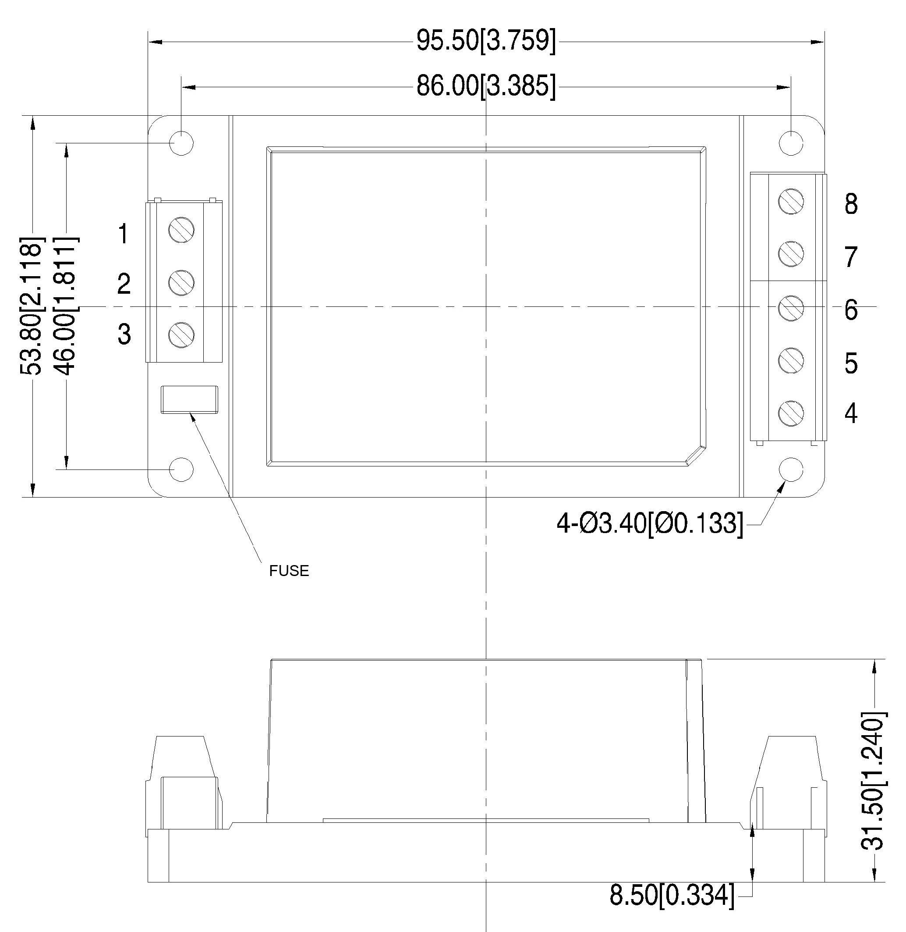
Terminal No. | Function
1 | FG (No function)
2 | AC(N)
3 | AC(L)
4 | +Vout
5 | NC
6 | NC
7 | NC
8 | -Vout
Note:
Unit: mm[inch]
Lead Wire 24-12AWG
Screwing torque: 0.4 N.m Max
General tolerance: ±1.00[±0.039]

F2-TS Packaging Dimension
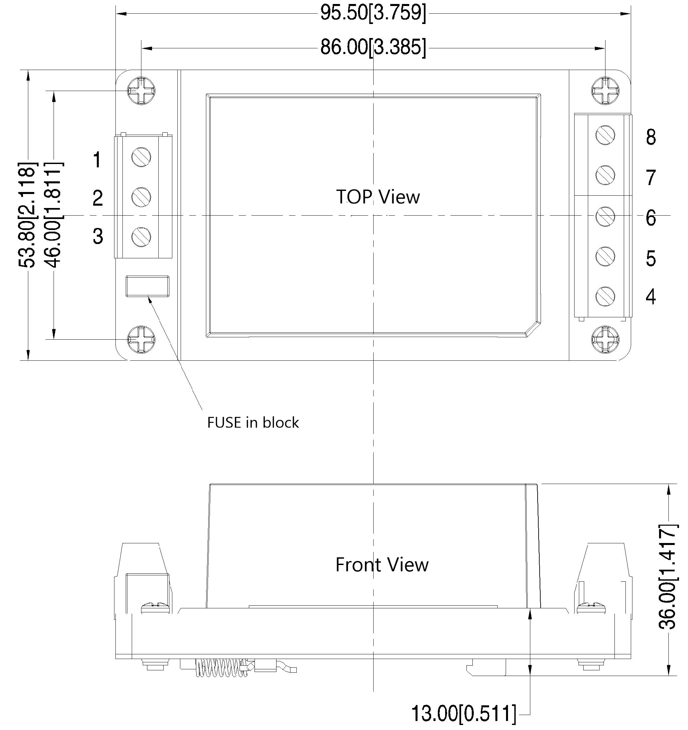
Note:
Unit: mm[inch]
Lead Wire 24-12AWG
Screwing torque: 0.4 N.m Max
General tolerance: ±1.00[±0.039]
Terminal No. | Function
1 | FG (No function)
2 | AC(N)
3 | AC(L)
4 | +Vout
5 | NC
6 | NC
7 | NC
8 | -Vout
Packaging Code | Dimensions L x W x H
F2 | 62.0 x 45.0 x 22.5 mm | 2.441 × 1.772 × 0.886 inch
F2-T | 95.5 x 53.8 x 31.5 mm | 3.759 × 2.118 × 1.240 inch
F2-TS | 95.5 x 53.8 x 36.0 mm | 3.759 × 2.118 × 1.417 inch

Ripple & Noise Test Instructions (Twisted Pair Method, 20MHz Bandwidth)
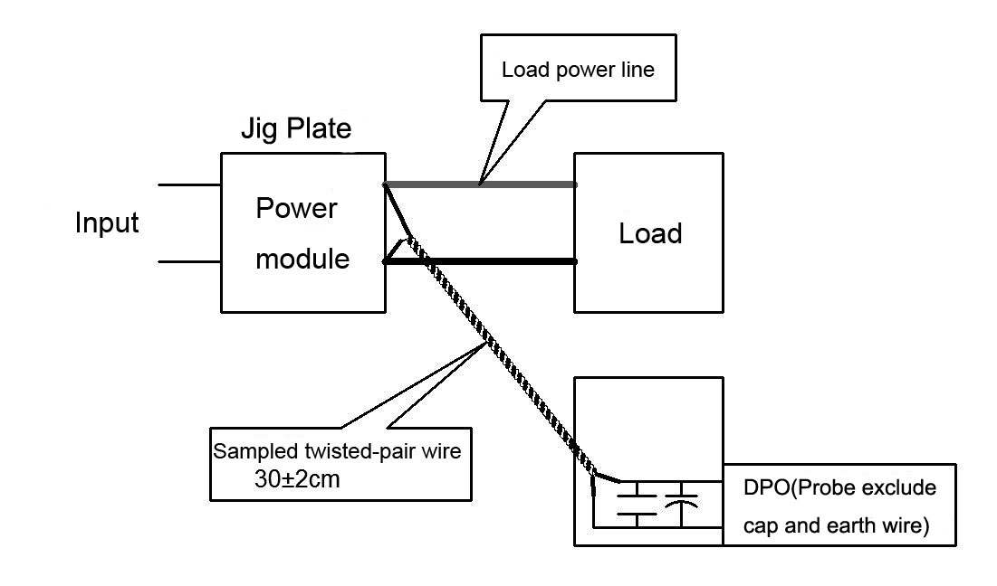
1) The Ripple & noise test need 12# twisted pair cables, an oscilloscope which bandwidth should be set to 20MHz, 0.1uF polypropylene capacitor and 10uF high-frequency low-resistance electrolytic capacitor are connected in parallel with the probes (100M bandwidth). The oscilloscope should be set at the Sample Mode.
2) The test diagram is shown on the right. The converter output connects to the electronic load by the jig with cables which size should be defined according to the output current value. The twisted pair (length 30cm±2 cm) should be connected in parallel with the load, the location is as close as possible to the output pins or terminals. The test can be started after input power on.

Product Performance Curves
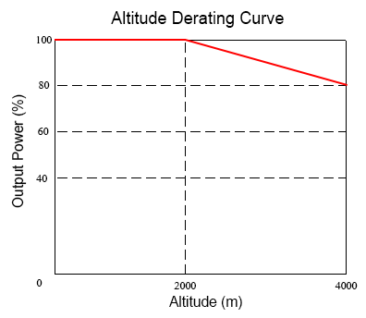
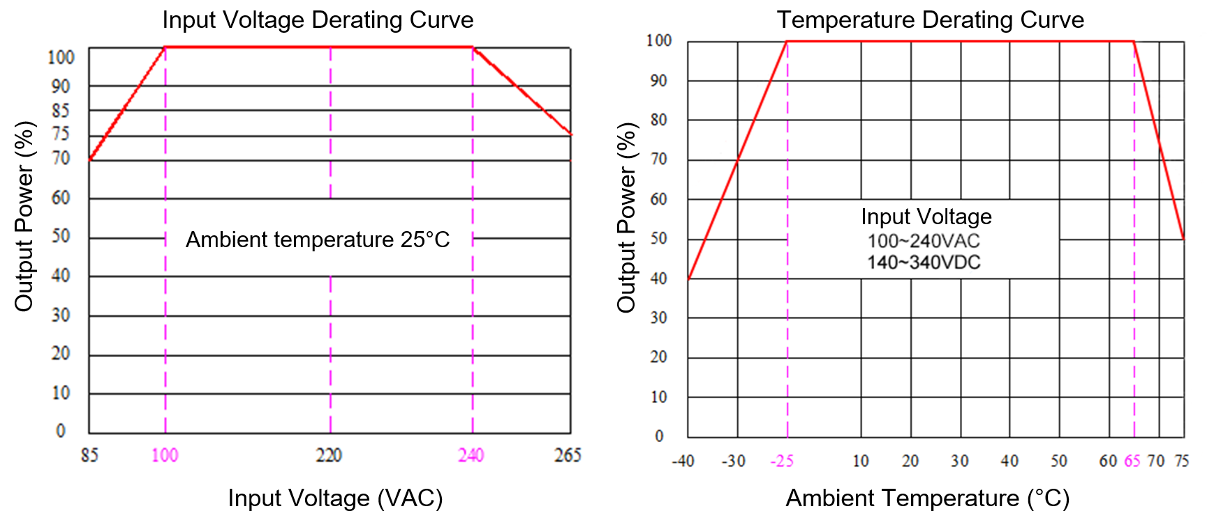
Note 1 - The output power should be derated based on the input voltage derating curve at 85~100VAC/240~265VAC /120~140VDC /340~380VDC.
Note 2 - This product should operate at a natural air condition, please contact us if it need be used at a closed space.
Recommended Circuit for Application
- Typical Application Circuit
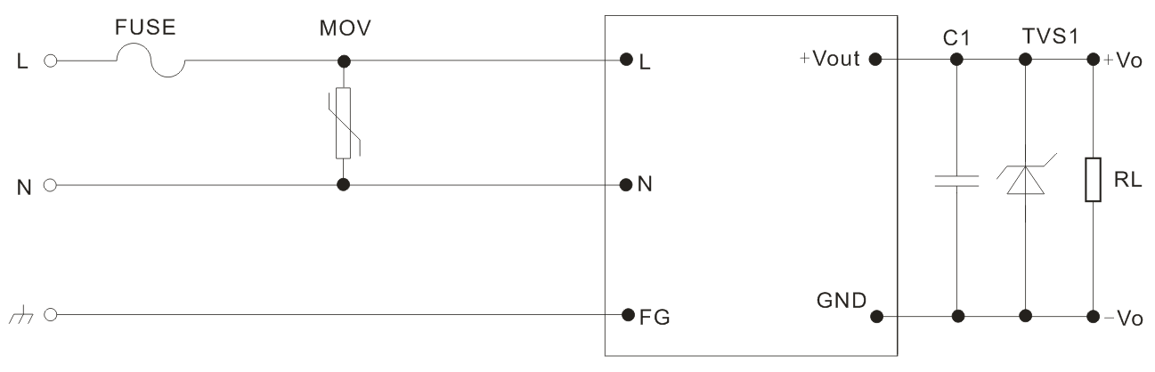
Circuit 1
Output Voltage | 3.3V | 5V | 9V | 12V | 15V | 20V | 24V
TVS1 | SMBJ7.0A | SMBJ7.0A | SMBJ12A | SMBJ20A | SMBJ20A | SMBJ30A | SMBJ30A
Note:
A ceramic SMD capacitor is recommended for C1 which can suppress the high-frequency noise; TVS is recommended to protect the output circuit at abnormal condition; 2A/250V Time-delay fuse is recommended; 14D511K/4500A is recommended for MOV.
- Recommended Circuit for EMC
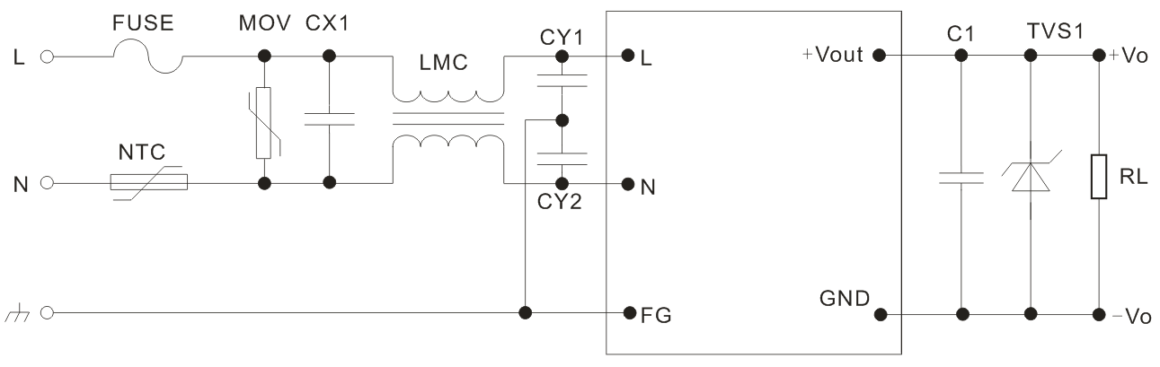
Circuit 2
Component | Recommended Value | Component | Recommended Value
MOV | 14D511K/4500A | NTC | 5D-9
CX1 | X2/104K/275VAC | LMC | 15mH/0.5A
FUSE | 2A/250V, Time-delay fuse (necessary) | - | -
CY1, CY2 | Y1/102M/400VAC | - | -
Application Notice:
1.The products should be used according to the specifications in this datasheet, otherwise it could be permanently damaged.
2. A fuse should be connected at input.
3. The product performance in this datasheet cannot be guaranteed if it works at a lower load than the minimum load defined.
4. The product performance in this datasheet cannot be guaranteed if it works under over-load condition.
5. Unless otherwise specified, all values or indicators in this datasheet are tested at Ta=25℃, humidity<75%RH, nominal input voltage and rated load (pure resistance load).
6. All values or indicators in this datasheet had been tested based on Aipupower test specifications.
7.The specifications are specially for the parts listed in this datasheet, any other non-standard model performances could be out of the specifications. Please contact our technician for specific requirements.
8. Aipupower can provide customization service.

Guangzhou Aipu Electron Technology Co., Ltd
Address: Building 4, HEDY Park, No.63, Punan Road, Huangpu Dist, Guangzhou, China.
Tel: 86-20-84206763 Fax: 86-20-84206762 Hotline: 400-889-8821
E-mail: sales@aipu-elec.com Website: https://www.aipupower.com

